**Project Description**

1. **Project Structure**

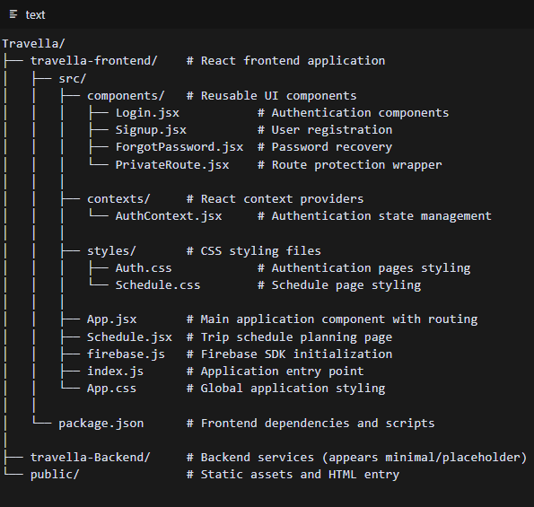

1. **Authentication Features** 
   1. Firebase Authentication is implemented for user management
   2. Login/Signup flows with proper validation
   3. Password Recovery functionality
   4. Protected Routes using React Router and context
2. **Main Application Features** 
   1. Travel Planning Form that collects:
   2. Destination city
   3. Trip dates
   4. Budget amount (in SAR)
   5. Activity preferences
   6. **Schedule Creation with:**
      1. Day-by-day itinerary planning
      2. Drag-and-drop activity management
      3. Morning/afternoon/evening time slots
      4. Activity suggestions based on preferences
3. **Firebase Integration**
   1. Firebase Authentication for user management
   2. Project ID: authentication-in-react-60fa1
   3. Auth methods implemented:
   4. Email & Password authentication
   5. Password reset functionality
4. **Key Technical Components**
   1. React Router for navigation and route protection
   2. React Context API for state management
   3. Firebase SDK for authentication
   4. Hello-Pangea DnD (React Beautiful DnD fork) for drag-and-drop
   5. CSS Modules for component styling
5. **User Experience Flow**
   1. User creates an account/signs in
   2. User enters travel details (destination, dates, activities, budget)
   3. User is directed to a schedule creation page
   4. User can drag and drop activities to create a personalized itinerary
   5. Replaced activities are returned to the activity pool instead of being lost
6. **Dependencies**
   1. React 19 (latest version)
   2. Firebase Authentication
   3. React Router DOM (v7)
   4. Hello-Pangea DnD

**Code Snippets**



